***Assignment 5***

***SQL Nested Queries***

***DBMS LAB***

**NAME-Ashish Goyal**

**ID-2016ucp1100**

**BATCH –A 1, 2**

**Schema :** employees(employee_id,firstname,lastname,email,phoneno,jobid,managerid,salary,commissionpercent,deptid);

Insert data with employee id from 155 to 170.

Create employees table:

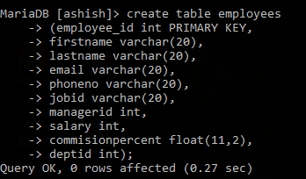

Insert values in the employees table:

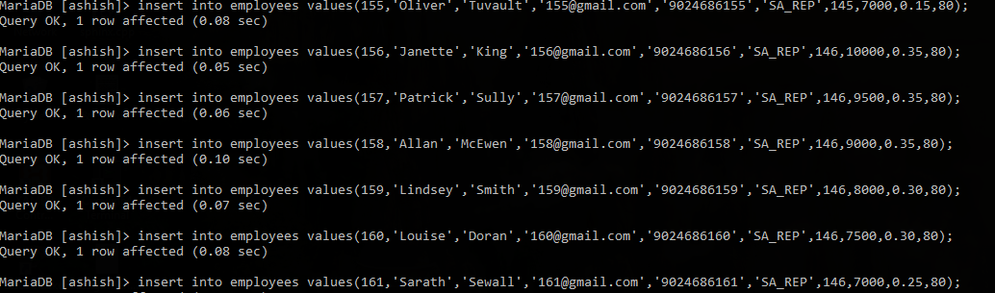

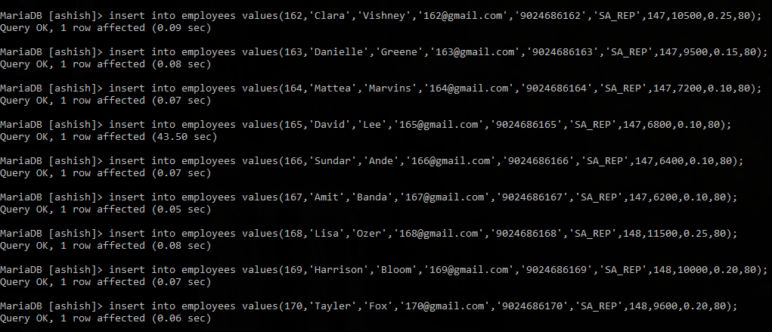

Displaying content of table employees

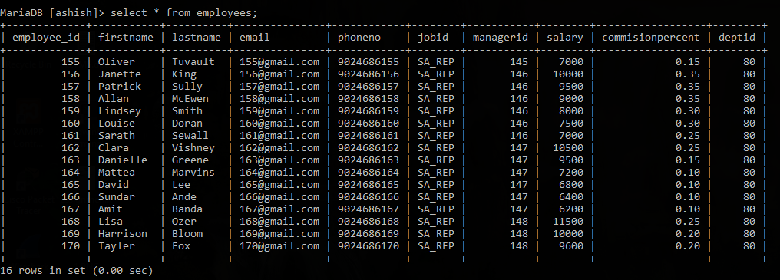

Update some values in the table (for better understanding of given queries)

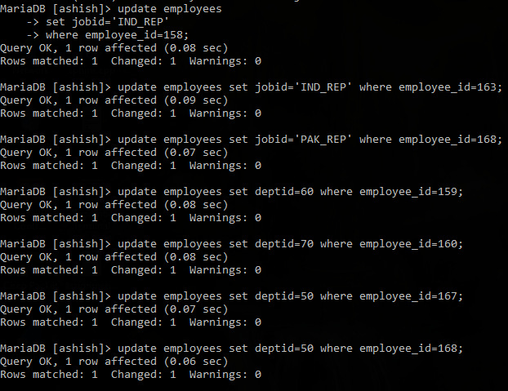

Displaying content after some updation:

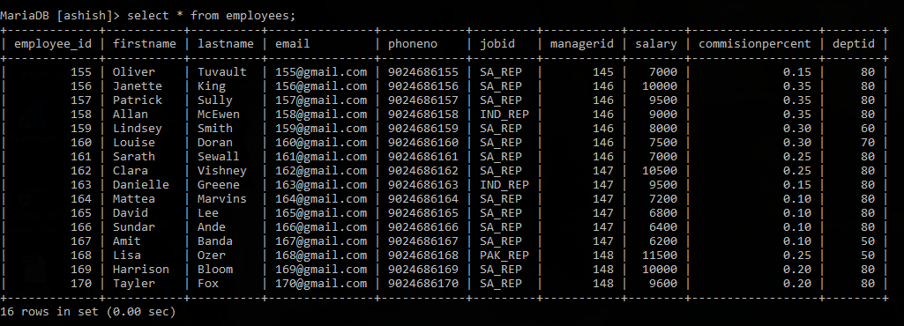

QUERIES:

1. Write a query to display the name (first name and last name) for those employees who gets more salary than the employee whose ID is 163.

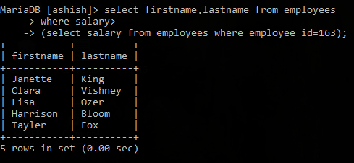

1. Write a query to display the name (first name and last name), salary, department id, job id for those employees who works in the same designation as the employee works whose id is 169.

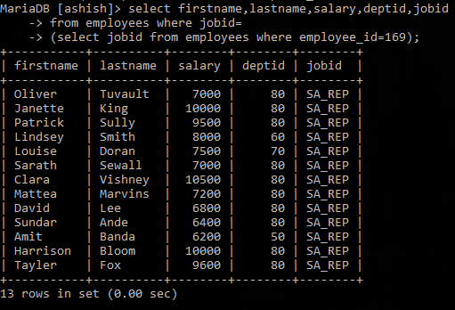

1. Write a query to display the name (first name and last name), salary, department id for those employees who earn such amount of salary which is the smallest salary of any of the departments.

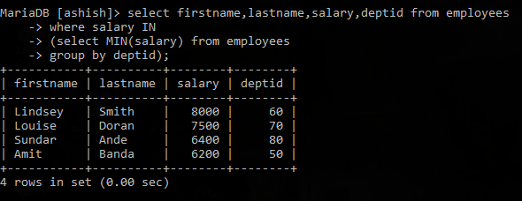

1. Write a query to display the employee id, employee name (first name and last name) for all employees who earn more than the average salary.

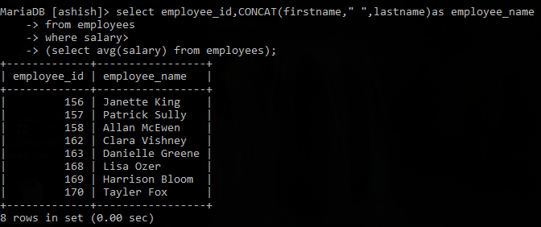

1. Write a query to display all the information of an employee whose reporting person id is 161 and 162 respectively.



1. Write a query to display all the information of the employees whose salary is within the range of smallest salary and 2500.

